DATABASE SCHEMA

**Submitted by:**

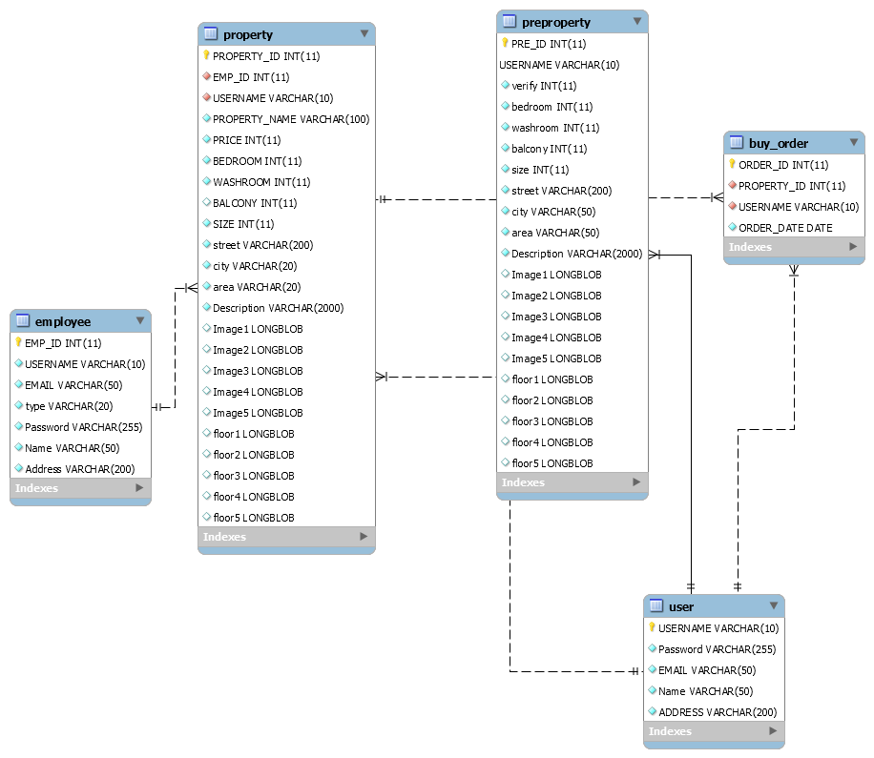

Contribution Summary

**[17101400] [Abu Sadat Md. Munim]**

Backend for agent.php, agentAccept.php, agentForm.php, agentReject.php, admin.php, adminForm.php, accept.php

**[17101076] [Atique Morshed]**

Frontend and backend for login.php, loginAdmin.php, registration.php, sellHouse.php, buyconfirm.php, resources/regFunc.php

Frontend for agent.php, agentForm.php, admin.php, adminForm.php

Refactored all codes.

ER Diagram, Schema

**[17101072] [Tasnimul Karim Ayon]**

Backend and frontend for Index.php, search.php, function.php, categories.php, action.php

Refactored all codes.

ER Diagram, Schema

**[17101155] [Farhan Md. Siraj]**

Backend and frontend for single-list.php

**[17301003] [Saad Rafsan Goni]**

Data entry, Data management

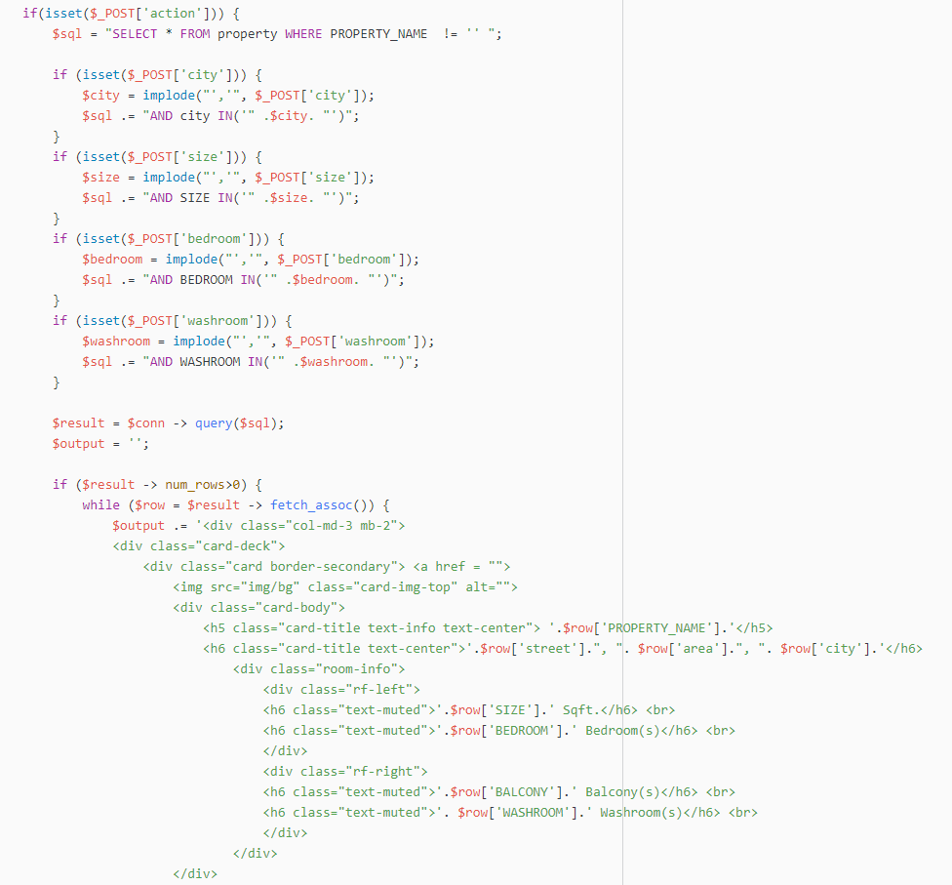**Product Filter**

**Place Order**

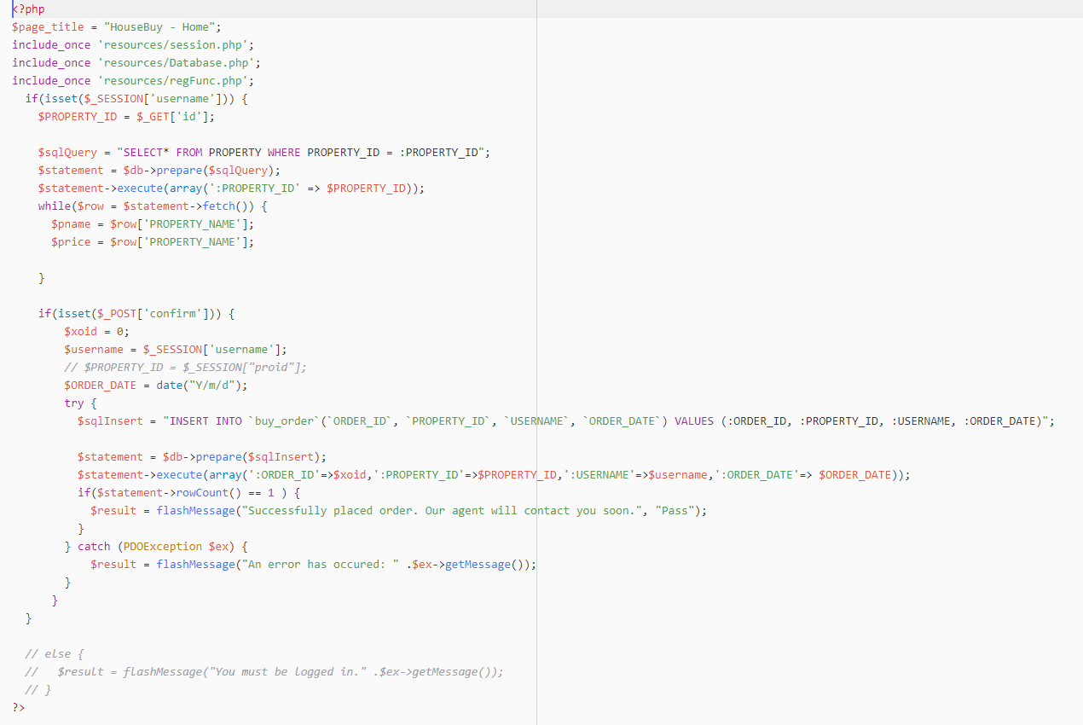

**Search Result**

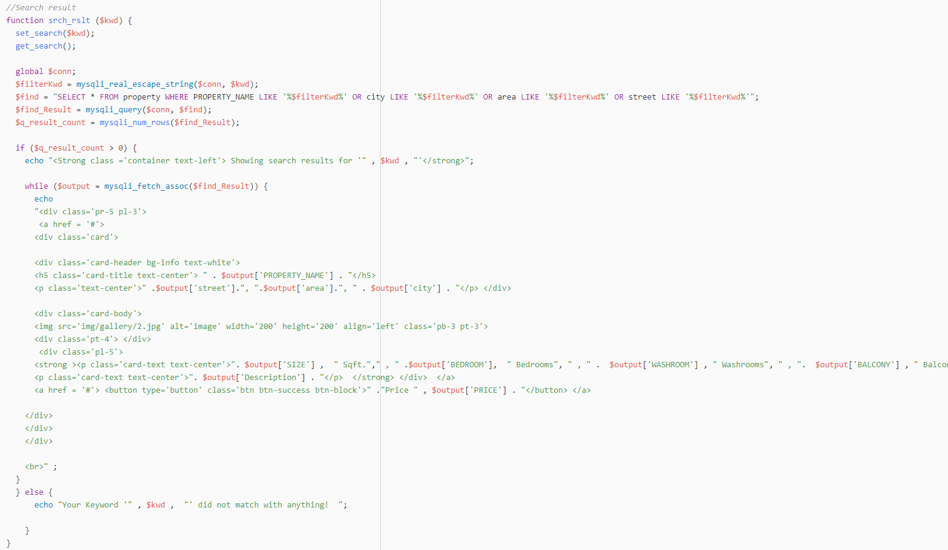

**House Sell form**

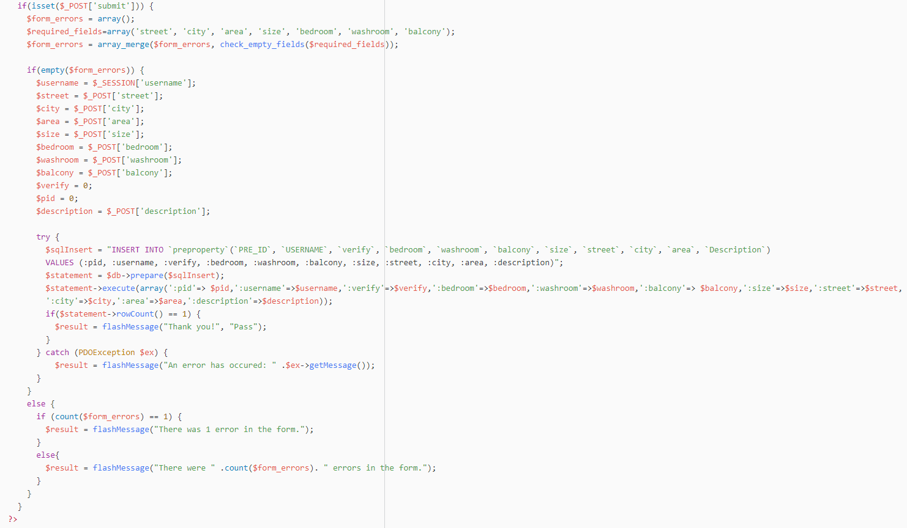

**Agent Verification**

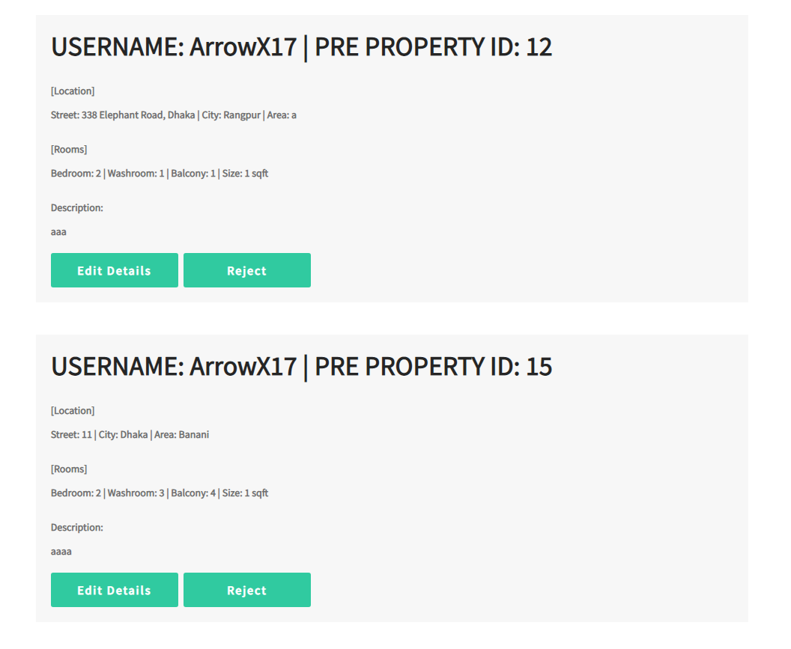

**Sell property form for PRE PROPERTY TABLE**

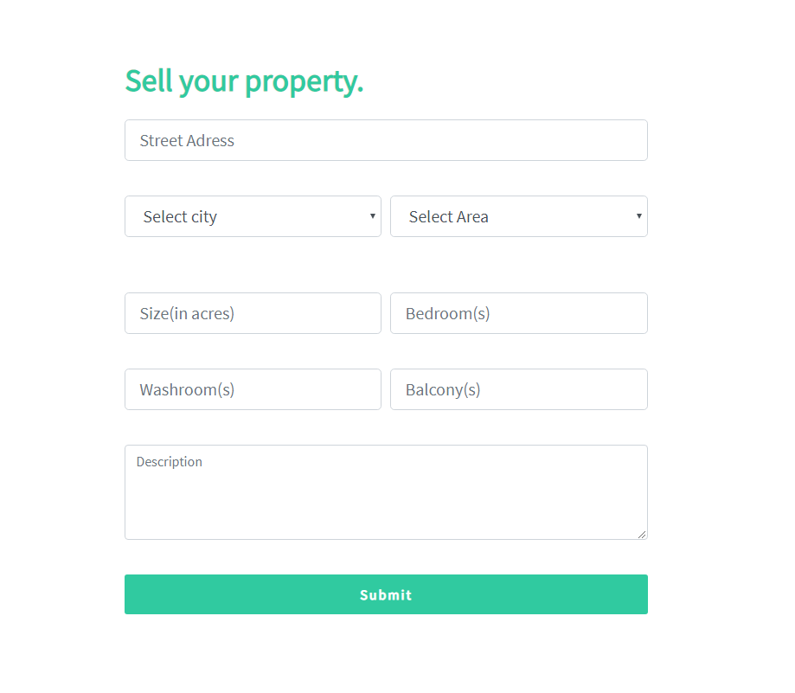

**FILTER**

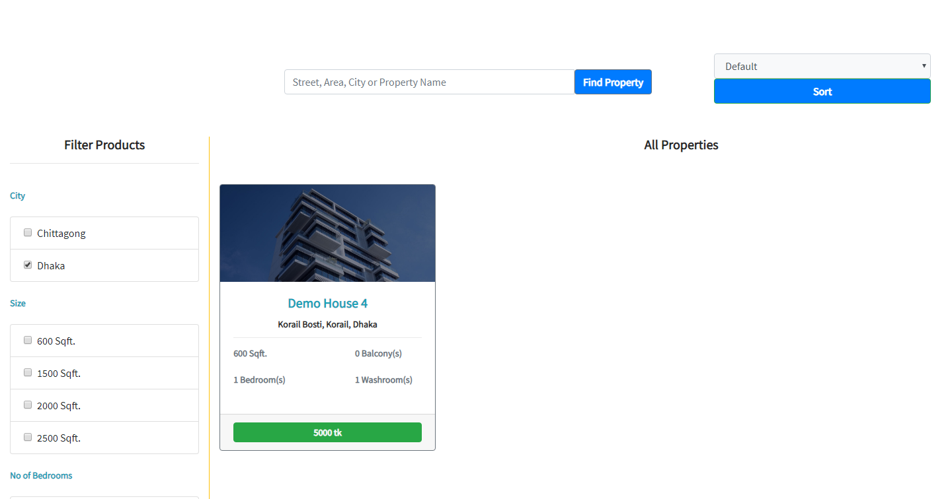



**CSE 370**

**DATABASE SYSTEM**

**PROJECT: HouseBuy Ecommerce**

**Date: 2019.08.05**

|  |
| --- |
| 17101400 | Abu Sadat Md. Munim  17101076 | Atique Morshed  17101072 | Tasnimul Karim Ayon  17101155 | Farhan Md. Siraj  17301003 | Saad Rafsan Goni |
|  |

**Section: 05**

**Submitted by:**